1. **Set the proxy of jenkins**
2. Click manage jenkins

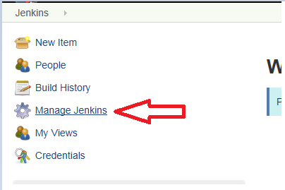

1. click manage plugins

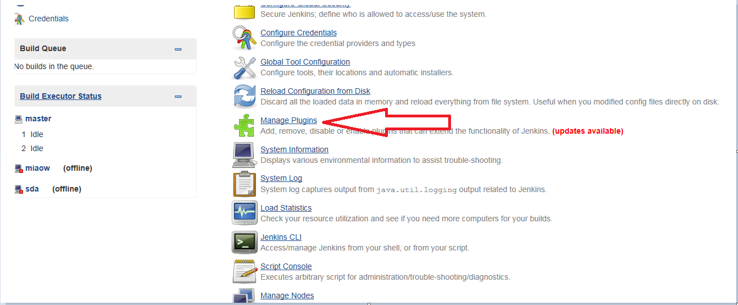

1. click advanced

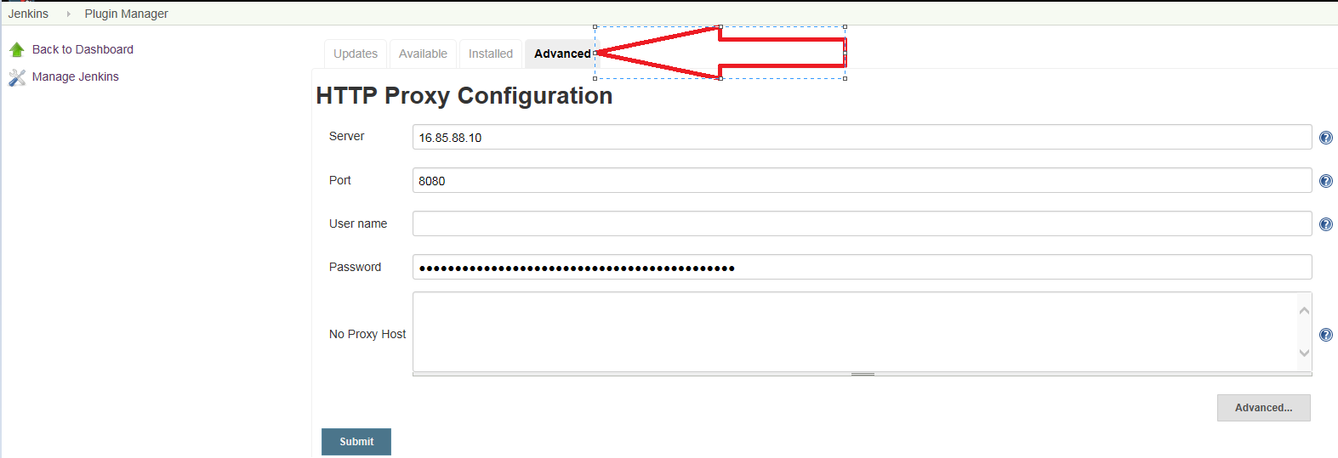

1. set your proxy and submit
2. restart jenkins
3. **Download pipline**
4. Install plugin (Pipline)



1. Install Github plugin



1. Copy the code to the pipline
2. Click New Item

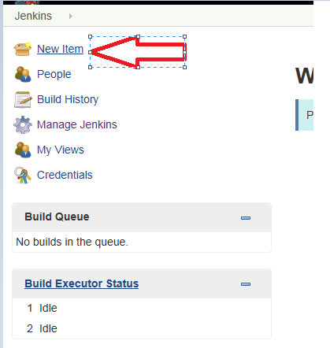

1. Create pipline and set the pipline’s name

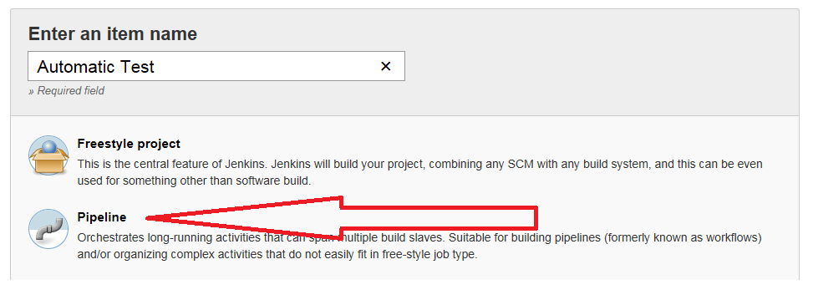

This time I set the name is Automatic Test and click Ok

1. Copy the code from github

The address of github is

<https://github.hpe.com/GHE-Automation/stephen-test/blob/master/jenkinsfile>